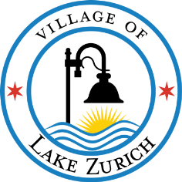

Wednesday, January 15, 2025 4 - 6 p.m.

Public Notice is hereby given that there will be a community open house special meeting of the Lake Zurich Village Board and Planning & Zoning Commission on Wednesday, January 15, 2025 from 4 to 6 pm. This community open house meeting will be held at Vault 232 in Lake Zurich at 35 W. Main Street in accordance with the Illinois Compiled State Statues

SPECIAL MEETING AGENDA

1. CALL TO ORDER AND ROLL CALL

Village Board: Mayor Thomas Poynton, Trustee Mary Beth Euker, Trustee Jake Marx, Trustee William Riley, Trustee Marc Spacone, Trustee Roger Sugrue, Trustee Greg Weider.

PZC Commissioners: Chairperson Orlando Stratman, Vice-Chair Antonio Castillo, Joe Giannini, Sean Glowacz, Vladimir Kovacevic, Scott Morrison, Mike Muir and Ildiko Schultz.

2. PUBLIC COMMENT

Village Trustees and Commissioners will be available throughout this open house to speak with residents who want to comment on matters related to the draft Lake Zurich Comprehensive Plan.

3. WORKSHOP TO REVIEW AND DISCUSS DRAFT COMPREHENSIVE PLAN

4. ADJOURNMENT

The Village of Lake Zurich is subject to the requirements of the Americans with Disabilities Act of 1990. Individuals with disabilities who plan to attend this meeting and who require certain accommodations so that they can observe and participate in this meeting, or who have questions regarding the accessibility of the meeting or the Village’s facilities, should contact the Village’s ADA Coordinator at 847.438.5141 (TDD 847.438.2349) promptly to allow the Village to make reasonable accommodations for those individuals.

*Agenda posted on January 10, 2025.

